Saints Hockey Club 2014

Player Information for 2014
First Name: Surname:

*Address: Suburb: Postcode:

Phone Number: Mobile Number:
Email: D.O.B:
Other Information:

Team:
Senior Junior

Men Women U/13 U/15 U/17

Specific division for senior teams (if wish to indicate): (1st, 2nd, 3rds)

Emergency Contact Information:
1st Contact

Name: Surname:

Ph: Email:

Relationship to player:

2nd Contact

Name: Surname:

Ph: Email:

Relationship to player:

Do you have private health insurance? YES NO
Do you have Ambulance cover? YES NO
Allergies or other medical conditions:

Personal details will be kept confidential by the manager or coach and taken to all training sessions and matches. Information will only be used in an emergency.
Hockey Victoria Membership Registration:
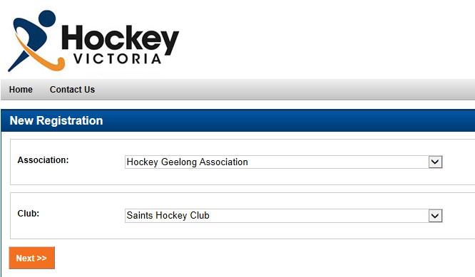
Please complete the online registration form for your membership to Hockey Victoria. It’s very simple and doesn’t take very long. The link to the site is below...
https://memberdesq.imgstg.com/index.cfm?fuseaction=main&OrgID=10870
Select the options and then click next to complete the registration.

2014 Fees:
All players please note the following changes to the 2014 fees:

Group | Club Fees | Match Fees
Seniors | $185.00 | $10.00
Students | $135.00 | $7.00
Juniors | $85.00 | $5.00

The additional $15 on each of the club fees are due to the introduction of a mandatory Hockey Victoria Membership Fee.

If there are any players that cannot commit to the entire season they are requested to pay the following amounts per game:

Group | Club Fees | Match Fees
Seniors | $10.00 | $10.00
Juniors | $5.00 | $5.00

As soon as they qualify for finals (ie. play 9 games for Seniors or 7 games for Juniors) they will be notified and requested to pay the remainder of the club fees.
We have also introduced special discounts for families who play for the club which are outlined below:

Number of Family Members Discount

3 family members | 10%
4 family members | 15%
5 family members | 20%

Please note that this is only available for families living in the same household and with 2 full time jobs and therefore does not include families with more than 2 senior fees.
If you require any clarification or further information please contact Cassie O’Reilly on 0412 245 470 or by email at cassieoreilly@hotmail.com.

Return completed form to saintshockeyclub@hotmail.com or mail to;
Saints Hockey Club C/- 29 Kingsley Drive, Corio 3214

